**Assignment: Counter**

You need to keep track of how many times the same visitor visits a certain page. To do this, you will first need to write a basic counter. Create two pages, one that will show you how many times someone has visited the other.

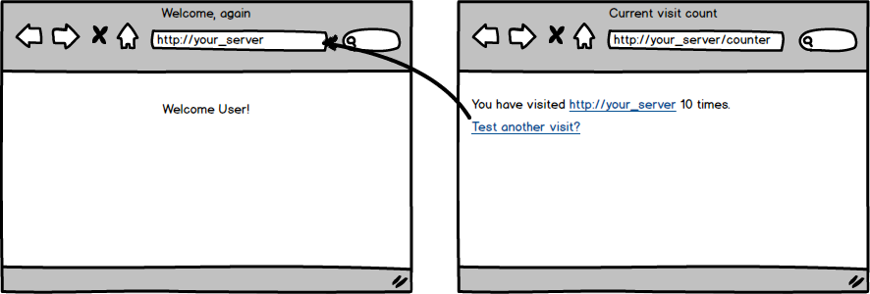

Topics:

* Session

Tasks:

* Create and display a counter on http://your_server/counter
* Increment the counter on each visit to http://your_server/
* Counter must start at zero
* No errors regardless of which page is visited first

Optional Challenges:

* Create a third page that will increment the counter by 2
* Create a reset button to set the counter back to zero